

**Software Requirements Specification**

*COSC2299 Software Engineering: Process and Tools (2350)  
Group P7_7*

#### 

Team:

Ashley Mullin - s3937907

Clarence O'toole - s3943755

Jaspal Singh-Walia - s3899925

Manik Thapliyal - s3953664

Sri Kalyan Rohan - s3958905

Ramon Aguila - s3840883

Table of Contents:

Revision History 2

Functional Requirements 3

Non-functional Requirements 3

Wireframes 4

1. Product Page 4

2. Landing Page 5

3. Profile (My Orders) 6

4. Profile (Personal Information) 7

5. Profile (Account Settings) 8

6. Profile (Wishlist) 9

7. Item Page 10

8. Shopping Cart 11

9. Checkout 12

10. Registration Page 13

11. Login Page 14

Architecture 15

Tools and Technologies Used 16

User Stories 16

Tests 25

# Revision History

| **Name** | **Date** | **Reason for changes** |
| --- | --- | --- |
| Ramon | 19/08/23 | Removed product backlog,  sprint 1 and 2 backlogs, and  Sprint 0 retro. These are uploaded on GitHub as separate documents |
| Ramon | 11/09/23 | Updated SRS document according to feedback from Milestone 1   * Added numbers to wireframes * Added to architecture “tools and technologies used” * Added sections for functional and non-functional requirements * Fixed grammar mistakes |
| Ramon | 17/09/23 | Updated functional requirements based on changes discussed with Product Owner. |
| Clarence | 17/09/23 | Added UML Diagrams |

# Functional Requirements

**Milestone 2**

**Search:** Users should be able to search for grocery products based on keywords.

**Viewing an item:** Users should be able to view an item’s information.

**Cart:** Users should be able to add items to their cart, remove unwanted items and edit quantities of selected items.

**Checkout:** Users should be able to purchase the items in their cart.

**Delivery:** Users should be able to order their items for delivery with a range of delivery options, based on the store.

**Milestone 3**

**Notifications:** Users should be able to receive notifications for special offers or if their favourite items are on sale.

**Changes made:** Due to unforeseen events, the product owner and development team decided to remove our enhancement feature, user registration and login, and replace it with Notifications instead.

# Non-functional Requirements

**Usability**: The user interface should be intuitive and easy to use, with clear navigation and responsive design for various devices.

Reliability:

**Maintainability**: Code should be well-documented and modular to allow for easier maintenance and updates.

**Performance**: The application should have a response time of less than 2 seconds for common user actions (e.g., searching for products, adding/removing items from the cart) to ensure a smooth user experience.

# Wireframes

### Product Page

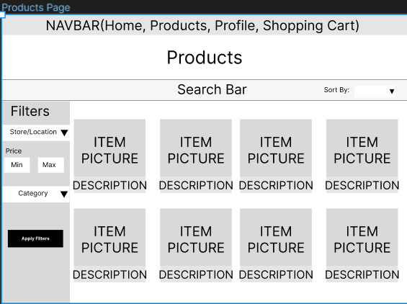

### Landing Page

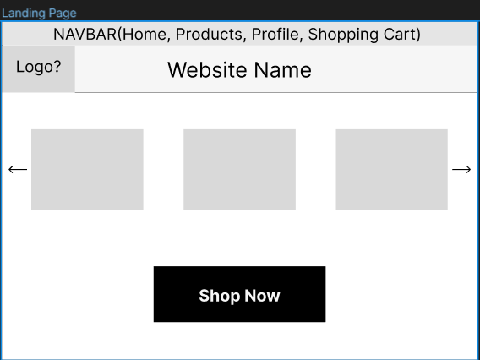

### Profile (My Orders)

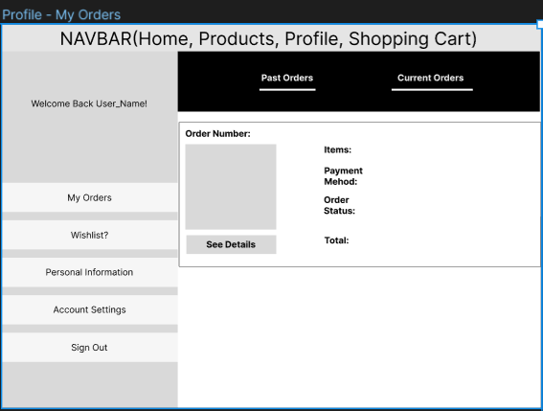

### Profile (Personal Information)

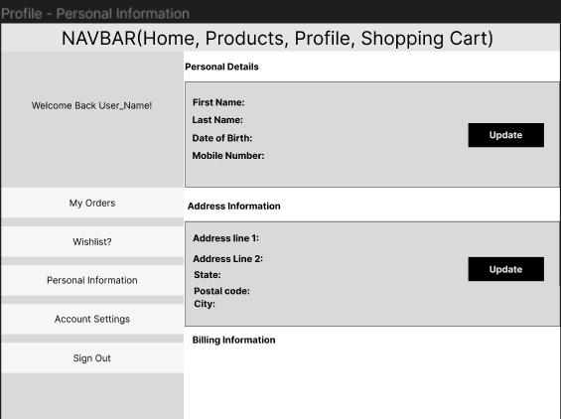

### Profile (Account Settings)

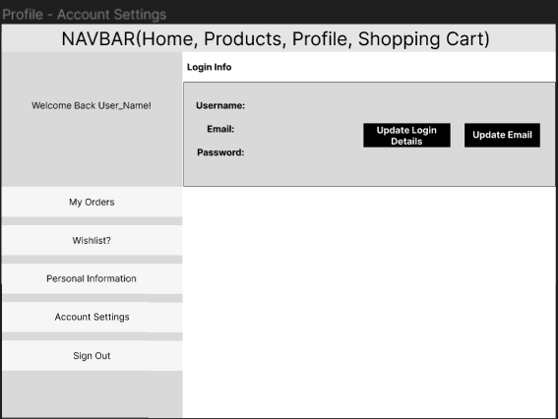

### Profile (Wishlist)

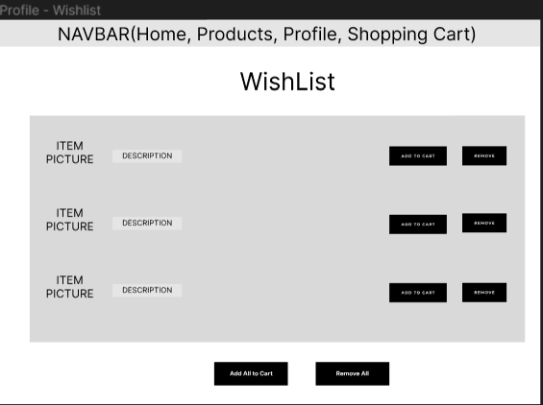

### Item Page

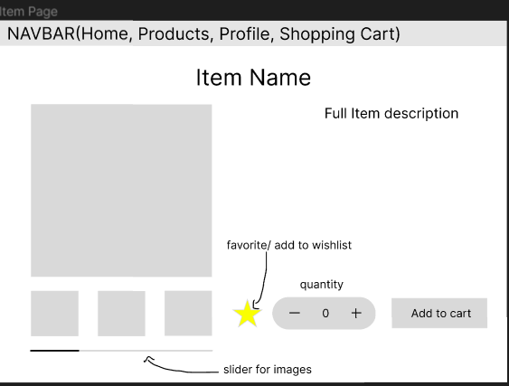

### Shopping Cart

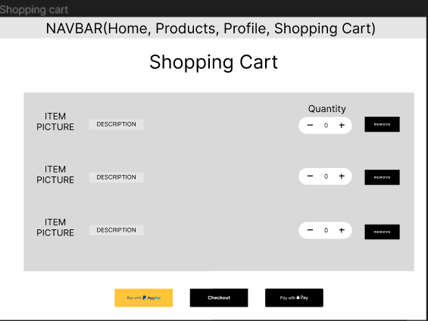

### Checkout

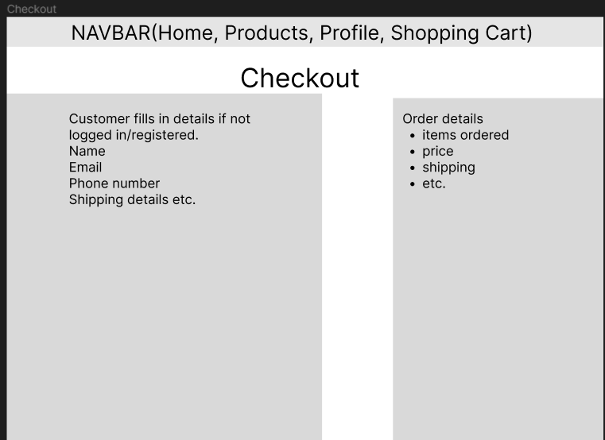

### Registration Page

# 

# 

# 

# 

# 

### Login Page

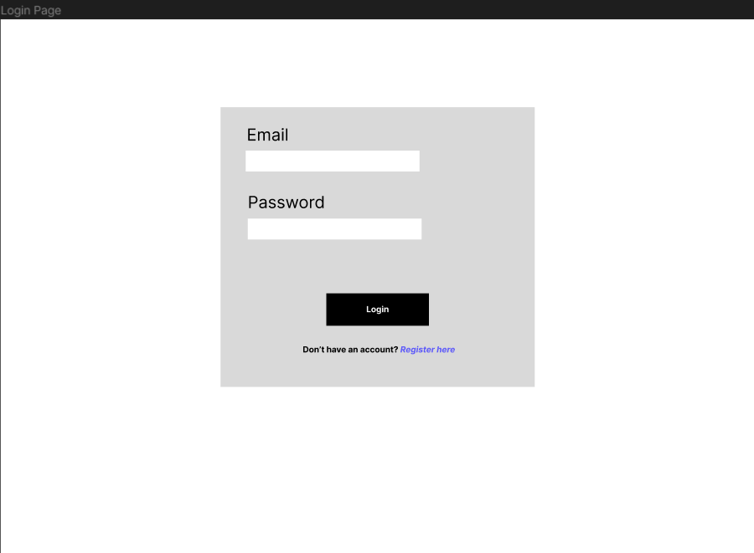

# Architecture

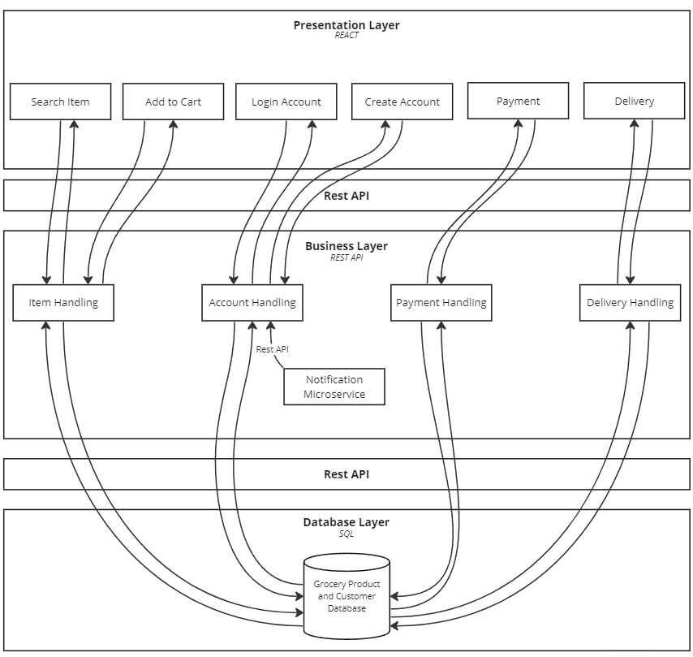

*Figure 1.0 - System architecture diagram*

Component explanation:

* **Search Item:** This component will allow the user to query the product database and return a list of relevant products.
* **Add to cart:** Add an item to a particular user’s cart.
* **Login account:** allows a user to log in and access their account.
* **Create an account:** New users can create a new account.
* **Payment:** prompts the user to pay for their order; choosing a select payment service.
* **Delivery:** will show delivery status for orders.
* **Item Handling:** will consult the item database depending on the user filters or will place items into the user’s cart.
* **Account handling:** will handle login information and relevant user information.
* **Payment handling:** will handle user payment and ensure the correct amount is charged.
* **Delivery handling:** will calculate delivery details; time, location, and status.
* **Grocery product and customer database:** using SQL to store the data, it will contain all items such as cost and stock *and user reviews*, user information which will contain usernames and passwords, and transaction history.
* **Notification microservice:** This microservice is responsible for sending any notification to the corresponding user account on the website.

### Tools and Technologies Used

**Rest API** is used to communicate between layers of the system. This allows for a modular design which will increase security as there is no direct connection between the presentation layer and the database as well as making it easier to develop as no team requires the other to finish their feature to start implementing their feature.

The **H2 database** is used for our database as it is easy to use, which helps our team save time and makes things simpler. We use it to store and manage data for products and shopping carts, and the H2 database is great at handling this kind of information. It also does not use a lot of computer resources and can easily fit into our application, making it a perfect match for our goal of making development smoother and more efficient.

**Maven dependencies** are used to help make software development more efficient and reliable, as they provide us with a pre-built framework that is organised and well-tested.

**React** is used to develop the front end as it helps us build user-friendly websites quickly. It helps keep our code organised and automatically updated, making it easier to add changes and debug errors.

# User Stories

**Definition of done**

* Code is written by multiple developers and/or peer-reviewed
* Unit tests cover 80% of situations, and all tests pass
* Functional testing based on acceptance criteria pass
* Implemented feature is intuitive to use, and passes usability tests
* Code tested and verified to work on website browsers (Chrome and Firefox), using Windows
* The code contains no known bugs
* Code is well-documented
* Code approved by the product owner

| **Story #1** | Search - Keywords | **Priority** | High |
| --- | --- | --- | --- |
| **Estimate** | 3 |
| As a | customer | | |
| I want to | Search for a product using keywords, | | |
| So that | can quickly find the item I'm looking | | |
|  | | | |
| Acceptance criteria | **Scenario: Search with results**  Given I am on the products page and have entered keywords of the item in the search bar, when the I click "search",  then the system will display products that include the keywords in the name, description or category.  **Scenario: Search with NO results**  Given I am on the products page and have entered the name of the item in the search bar and the item does not exist,  when I click "search",  then the system will display to my screen an error message, saying that the product does not exist. | | |

| **Story #2** | Search - Category | **Priority** | High |
| --- | --- | --- | --- |
| **Estimate** | 3 |
| As a | customer | | |
| I want to | browse different categories | | |
| So that | can explore a range of offerings from stores close to me | | |
|  | | | |
| Acceptance criteria | **Scenario: Viewing the categories**  Given I am on the home page,  when I click 'Categories',  then the system will display a list of categories that the user can select from.  **Scenario: Selecting a category and displaying results**  Given I have the categories displayed,  when I click a category,  then the system will display all the items from the selected category. | | |

| **Story #3** | Search - Viewing an item | **Priority** | High |
| --- | --- | --- | --- |
| **Estimate** | 2 |
| As a | customer | | |
| I want to | view an item's information | | |
| So that | I can make an informed decision about whether to purchase it | | |
|  | | | |
| Acceptance criteria | **Scenario: Displaying the item's information**  Given I entered a search and the system is displaying at least one item,  when I click on the item,  then the system will display the key information about the item.  *key information includes Name, description, stock availability, store and available delivery options.*  **Scenario: Displaying updated information**  Given I entered a search and the system is displaying at least one item,  when I click on the item,  then the system will display the updated information about the item.  examples of information changes can include price, stock availability and delivery options. | | |

| **Story #4** | Sorting results by price | **Priority** | High |
| --- | --- | --- | --- |
| **Estimate** | 3 |
| As a | customer | | |
| I want to | sort the search results from cheapest to most expensive | | |
| So that | I can choose from the cheaper options first | | |
|  | | | |
| Acceptance criteria | **Scenario: Sorting the search results**  Given I entered a search that displays at least one item,  when I click 'Sort by Price',  then the system will sort the items in ascending order of price. (Lowest price first, highest price last) | | |

| **Story #5** | Cart | **Priority** | High |
| --- | --- | --- | --- |
| **Estimate** | 5 |
| As a | customer | | |
| I want to | view my cart, | | |
| So that | I can check what items I’m missing or need to remove before checking out. | | |
|  | | | |
| Acceptance criteria | **Scenario: Viewing an empty cart**  Given I am a registered user,  when I click 'Cart' on the navigation bar,  then the system will direct me to the 'Cart' page and display a message saying, "The cart is currently empty".  **Scenario: Viewing cart with at least one item in it**  Given I am a registered user and I am on the homepage and I added at least one item in the cart,  when I click 'Cart',  then the system will direct the user to the 'Cart' page and display the items added to the cart.  **Scenario: Removing an item from the cart**  Given I am a registered user and I am on the 'Cart' page and there is at least one item in the cart,  when I click 'Remove item',  then the system will remove the selected item from the cart.  **Scenario: Editing quantity**  Given I am a registered user and I am on the 'Cart' page and there is at least one item in the cart,  when I click 'Edit' and enters a new number,  then the system will update the item quantity and total price accordingly. | | |

| **Story #6** | Adding an item to the cart | **Priority** | Medium |
| --- | --- | --- | --- |
| **Estimate** | 2 |
| As a | customer, | | |
| I want to | add an item to my cart | | |
| So that | purchase it together with other items | | |
|  | | | |
| Acceptance criteria | **Scenario: Adding a new item to the cart**  Given I am logged in to the website and I have an item page opened,  when I click 'Add to Cart',  then the system will add 1x item to the user's cart.  **Scenario: Adding an existing item to the cart**  Given I am logged in to the website and I have an item page opened and the item is already in the cart,  when I user click 'Add to Cart',  then the system will increase the item's quantity by one. | | |

| **Story #7.1** | Selecting delivery options | **Priority** | Medium |
| --- | --- | --- | --- |
| **Estimate** | 3 |
| As a | registered customer | | |
| I want to | be able to pick from a wide range of delivery options such as standard, express, and same-day | | |
| So that | I can select the best option that suits my needs | | |
|  | | | |
| Acceptance criteria | **Scenario: Delivery option drop-down**  Given I am on the 'Cart' page and I added at least one item in the cart,  when I click on 'Select delivery type',  then the system will display a drop-down bar, showing the available delivery options based on the items in the cart.  **Scenario: Updating the delivery price**  Given I am on the 'Cart' page and I have the delivery options open,  when I click on a delivery option,  then the system will display the new delivery price and add it to the grand total. | | |

| **Story #7.2** | Selecting delivery options | **Priority** | Medium |
| --- | --- | --- | --- |
| **Estimate** | 3 |
| As a | registered customer | | |
| I want to | designate a preferred window of time for my delivery to arrive | | |
| So that | my delivery does not arrive when I am away from the house. | | |
|  | | | |
| Acceptance criteria | **Scenario: Displaying delivery time frames**  Given I am on the 'Cart' page and I selected a delivery option,  when I click 'Select delivery time frame',  then the system will display a list of available delivery time frames.  **Scenario: Selecting a delivery time frame**  Given I am on the 'Cart' page and the list of available delivery time frames are displayed,  when I select a time frame,  then the system sets the order's delivery time to the selected time frame. | | |

| **Story #8** | Checkout | **Priority** | Medium |
| --- | --- | --- | --- |
| **Estimate** | 3 |
| As a | customer | | |
| I want to | check out my order | | |
| So that | I can pay and receive the items I ordered | | |
|  | | | |
| Acceptance criteria | **Scenario: Check out - Success**  Given I am on the 'Cart' page and I added at least one item in the cart and I have selected a delivery option  when I click 'Check out',  then the system will direct me to the payment page.  **Scenario: Check out - No items in the cart**  Given I am on the 'Cart' page and the cart is empty,  when I click 'Check out',  then the system will display an error message, saying that my cart is empty.  **Scenario: Check out - delivery option not selected**  Given I am on the 'Cart' page and the cart is empty,  when I click 'Check out',  then the system will display an error message, asking to select a delivery option.  **Scenario: Payment - Success**  Given I am on the 'Payment' page,  when I enter valid credentials,  then the system will process the order and display a message saying that my order has been placed.  **Scenario: Payment - Fail**  Given I am on the 'Payment' page,  when I enter invalid credentials,  then the system will display an error message, saying that the credentials entered are invalid. | | |

| **Story #9** | Notification preferences | **Priority** | Medium |
| --- | --- | --- | --- |
| **Estimate** | 2 |
| As a | customer | | |
| I want to | customise my notification preferences | | |
| So that | I can select what I receive notifications for | | |
|  | | | |
| Acceptance criteria | **Scenario: Accessing the notification preferences**  Given I am logged in and I am on the profile page,  when I click 'Notifications',  then the system will direct the user to the 'Notifications' page, displaying a list of notifications that can be toggled.  Notification items include promos, and price drops on favorited items.  By default, all notifications will be turned off.  **Scenario: Turning on notifications**  Given I am logged in and I am on the 'Notifications' page,  when I click 'ON' for a notification,  then the system will update their preferences and send timely notifications accordingly.  **Scenario: Turning off notifications**  Given I am logged in and I am on the 'Notifications' page and a notification is turned on,  when the user clicks 'OFF' for notification,  then the system will update their preferences and stop sending the user notifications. | | |

| **Story #10** | Notifications - Special offers | **Priority** | Medium |
| --- | --- | --- | --- |
| **Estimate** | 2 |
| As a | customer | | |
| I want to | promptly receive notifications about special offers | | |
| So that | I can take advantage of the promos before they expire | | |
|  | | | |
| Acceptance criteria | **Scenario: Receiving notifications**  Given I am logged in and I have notifications for special offers on,  when a store releases a promo,  then the system will send a timely notification to the user.  the notification will be displayed as a browser notification. | | |

| **Story #11** | Favoriting an item | **Priority** | Medium |
| --- | --- | --- | --- |
| **Estimate** | 2 |
| As a | customer | | |
| I want to | ‘favourite’ an item | | |
| So that | I can be notified when there is a promo or discount for the selected item | | |
|  | | | |
| Acceptance criteria | **Scenario: Favoriting an item**  Given I am logged in and I have the item page opened,  when I click the star button,  then the system will add the item into favourites and notify me when there is a promo or discount.  **Scenario: Un-favoriting an item**  Given I am logged in and the favourited item page opened,  when I click the star button,  then the system will remove the items from favourites and stop notifying me when there is a promo or discount. | | |

| **Story #12** | Registration | **Priority** | 3 |
| --- | --- | --- | --- |
| **Estimate** | Low |
| As a | new customer | | |
| I want to | create an account | | |
| So that | I can save my personal details for future purchases | | |
|  | | | |
| Acceptance criteria | **Scenario: Registering with a new email**  Given I am not already registered on the website,  when I register with a new email,  then the system will create a new account with the inputted information.  **Scenario: New customer profile**  Given I am registering with a new email,  when I fill in the form for creating a profile,  then the system will create the profile with the inputs from the form.  **Scenario: Existing customer**  Given I have already registered on the website,  when I register with my email,  then the system will display an error message saying that they already have an account, and display a hyperlink to the 'Login' page. | | |

| **Story #13** | Logging in | **Priority** | Low |
| --- | --- | --- | --- |
| **Estimate** | 1 |
| As a | registered customer | | |
| I want to | log in to my account | | |
| So that | I can access my account and make purchases | | |
|  | | | |
| Acceptance criteria | **Scenario: Logging in with valid credentials**  Given I am on the login page and I have an existing account in the system,  when I enter a valid email address and password,  then the system will redirect me to the homepage, displaying my username on the top right corner.  **Scenario: Wrong password**  Given I am on the login page and I have an existing account in the system,  when I enter an incorrect password,  then the system will display an error message, displaying that the user had inputted an incorrect credential.  **Scenario: Email is not registered**  Given I am on the login page and I do not have an existing account in the system,  when I enter an unregistered email and password,  then the system will display an error message, displaying that the user had inputted an incorrect credential. | | |

| **Story #14** | Personal details (Profile) | **Priority** | Low |
| --- | --- | --- | --- |
| **Estimate** | 1 |
| As a | registered customer | | |
| I want to | edit my personal details (name, address etc.) | | |
| So that | I can quickly check out my future purchases | | |
|  | | | |
| Acceptance criteria | **Scenario: Accessing profile**  Given I am logged in and I am on the homepage,  when I click 'Profile' on the navigation bar,  then the system will direct the user to the 'Profile' page.  *The profile includes name and address.*  **Scenario: Editing profile**  Given I am logged in and I am on my profile page,  when I click 'Edit profile',  then the system will display a form for changing the profile details.  **Scenario: Updating the profile**  Given I am logged in and I have the 'Edit Profile' form opened,  when I enter new information and clicks 'Update Profile',  then the system will update the profile information accordingly. | | |

# Tests

| **PBI item** | **Tests** |
| --- | --- |
| Search – Keywords | Test scenario-   1. User tries to search for items in the database using keywords. 2. Users use invalid keywords to search for items.   Test cases-   1. Products relevant to provided keywords are displayed. 2. An appropriate error message displayed. |
| Search - Category | Test scenario-   1. User has no category selected. 2. User has selected some category filters.   Test cases-   1. All items are displayed to the user. 2. Only items under relevant categories are displayed. |
| Viewing an item | Test scenario-   1. User selects item to view   Test case-   1. User is led to an item page containing relevant information like price and store item belongs to. |
| Sorting results by price | Test scenario-   1. User selects sorting method Price: low-high 2. User selects sorting method Price: high-low   Test cases-   1. All items are displayed in order of ascending price. 2. All items are displayed in descending price order. |
| Cart | Test scenarios-   1. User clicks on the cart icon. 2. User removes an item from the cart.   Test cases-   1. Cart information like item name, price, quantity and cart total is displayed. 2. Item quantity is reduced or item is removed from cart and cart total is updated. |
| Adding an item to the cart | Test scenario-   1. User adds an item to the cart. 2. Users select a quantity desired.   Test cases-   1. Item is added to cart or item quantity increases and updates the cart total. 2. Cart should add the item selected by the user with the correct quantity |
| Selecting delivery options | Test scenario-   1. User selects from available delivery options presented. 2. User does not select a delivery option   Test cases-   1. Delivery times and costs are displayed to the user. 2. User cannot proceed to payment yet |
| Checkout | Test scenario-   1. User selects checkout after selecting items. 2. Users selects checkout without having anything in cart.   Test cases-   1. Item costs, quantity and total price is displayed. 2. Error message stating there is nothing in the cart is displayed. |
| Notifications – | Test scenario-   1. Users accepts prompt to have notifications turned on 2. User declines to have notifications on   Test cases-   1. System should notify users if there is a special offer and system should notify users if their favourite item is on sale 2. System should not notify the user |
| Favoriting an item | Test scenario-   1. User clicks on star button on an unfavorited item to favourite an item 2. User clicks on star button on an favorited item to unfavourite an item 3. User is notified during a promotion 4. User is notified during a discount   Test cases-   1. System adds the item to the particular user’s favourite items list 2. System removes the item to the particular user’s favourite items list 3. System notifies user that an item they’ve selected has a promotion 4. System notifies user that an item they’ve selected has a discount |
| Registration | Test scenario-   1. User attempts to create account with all valid credentials typed in 2. User attempts to create account with existing email in the database 3. User attempts to create account with invalid formatting for email 4. User attempts to create account with missing data   Test cases-   1. System stores account information and a pop up shows that the account was successfully made which then can take them to the login page 2. System warns user with a pop up that the email is already in use and lets them retry or login 3. System warns user with a pop up that the email format is invalid and to retry 4. System should indicate which fields are missing |
| Logging in | Test scenario-   1. User types correct credentials to login 2. User types invalid credentials   Test cases-   1. System verifies the login information with the database and logs the user in and presents the homepage with their personal account 2. System warns user that the credentials inputted are incorrect but doesn’t specify which was incorrect and keeps them on the login page |
| Personal details (Profile) | Test scenario-   1. User edits and updates personal details successfully 2. User types incorrect syntax when editing personal details 3. User changes password   Test cases-   1. All changes are updated in the database and displayed on their profile 2. System displays error messages and details are not updated. 3. System should update user’s new password |

# UML

To create the database, we made a UML diagram to depict how different classes will associate with each other.

